Temple University

College of Engineering

Department of Electrical and Computer Engineering

**Student Lab Report Cover Page**

**Course Number: ECE 4513**

**Course Section: 1**

**Experiment # : Lab #2**

**Student Name : abdoul kader ousseini moussa**

**TUid : 915071476**

**Date : 09/22/2017**

**Grade: ______ /100**

**TA Name:** Ammar Ahmed

# Abstract

In this laboratory, we will generate a periodic waveform signal using Simulink then calculate it Fourier series coefficient with a spectrum analyzer and verify the coefficients by calculations. Also, we will calculate the normalized average power of the Fourier series using the Parseval’s theorem.

# Introduction

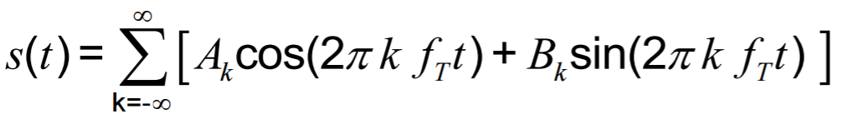For this lab, the periodic waveform signal has an amplitude of 6V, a period T= 1S and the signal is multiplied with a pulse generator. The resulting signal is connected to a spectral analyzer which give the Fourier series and their respective average power. The Fourier series theorem state any periodic signal can be represented as a sum of sine and cosine. The Eq.1 below gives the general formula where *fT* fundamental frequency.

**Eq.1**

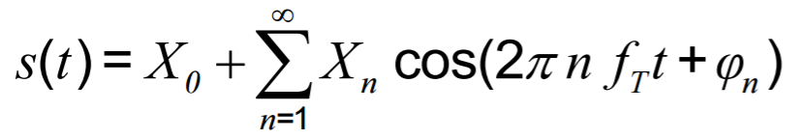The Fourier series of a harmonic signal can also be represented in polar form term of the real function as the Eq.2 below

**Eq. 2**

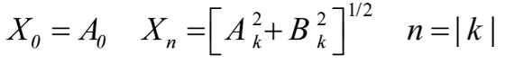Where X0 is the average or DC coefficient, and *Xn* is the coefficient of the phase shift. *Xn* can be found using the Eq.3 below

**Eq. 3**

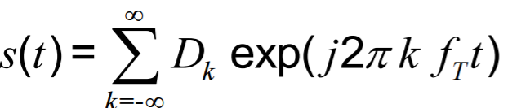 For a single-sided spectrum the Fourier series of a periodic signal can be found using the complex polar from Eq.4 below.

**Eq. 4**

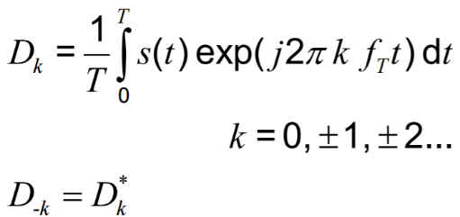Where

**Eq. 5**

# procedure and designs steps

* On the ramp wave block and amplitude 6.
* Multiply the ramp wave with a pulse generator.
* Use a Spectrum analyzer for the spectrum and a scope for the temporal signal.
* Calculate | Dm | for k =0,1 ,2, 3, 4,5
* Calculating the percentage of the total normalized average power %PAV for the summated polar *Xm* Fourier series coefficients for n = 0, 1, 2; n = 0, 1, 2, 3; n = 0, 1, 2, 3, 4; and n = 0, 1, 2, 3, 4, 5 using Parseval’s Theorem

# simulation Results

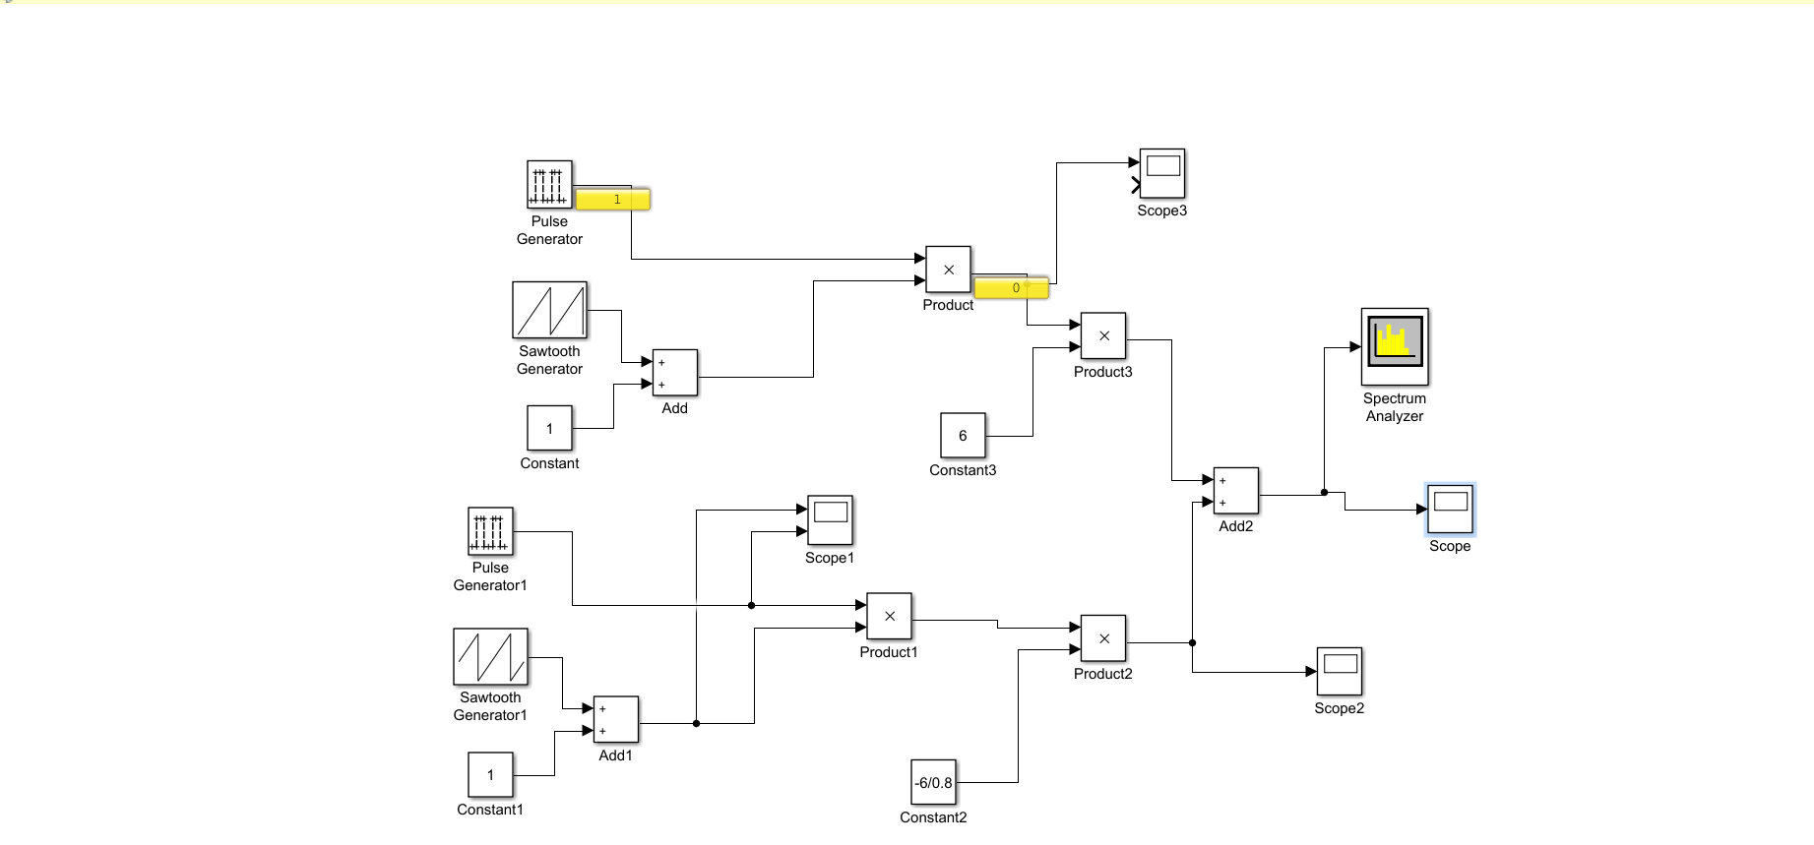

Figure 1 ramp-wave with pulse generator Simulink Block Diagram

The Figure 1 above show the Simulink block diagram for ramp-wave. This design has three stages, stage#1 is the ramp wave generation in discrete time with amplitude of 6V for a period of T= 0.5S . Stage#2 repeat the ramp wave with an amplitude =--6. Stage#3 add the two wave together .The spectrum analyzer show the signal spectrum and the scope show the temporal signal.

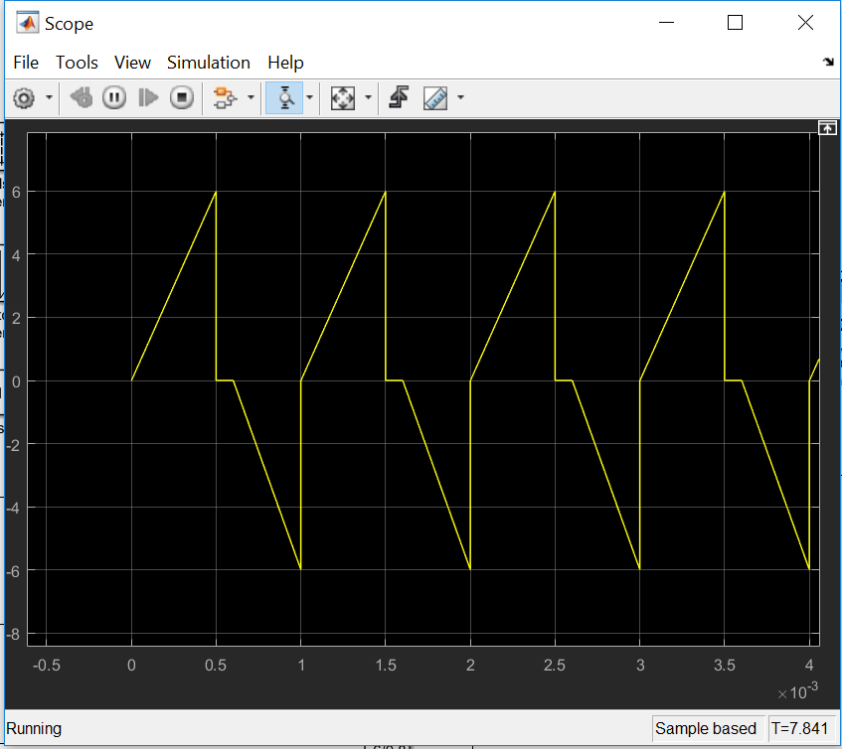

Figure 2 ramp-wave Signal

The Figure 2 above shows the temporal ramp wave for the whole signal.

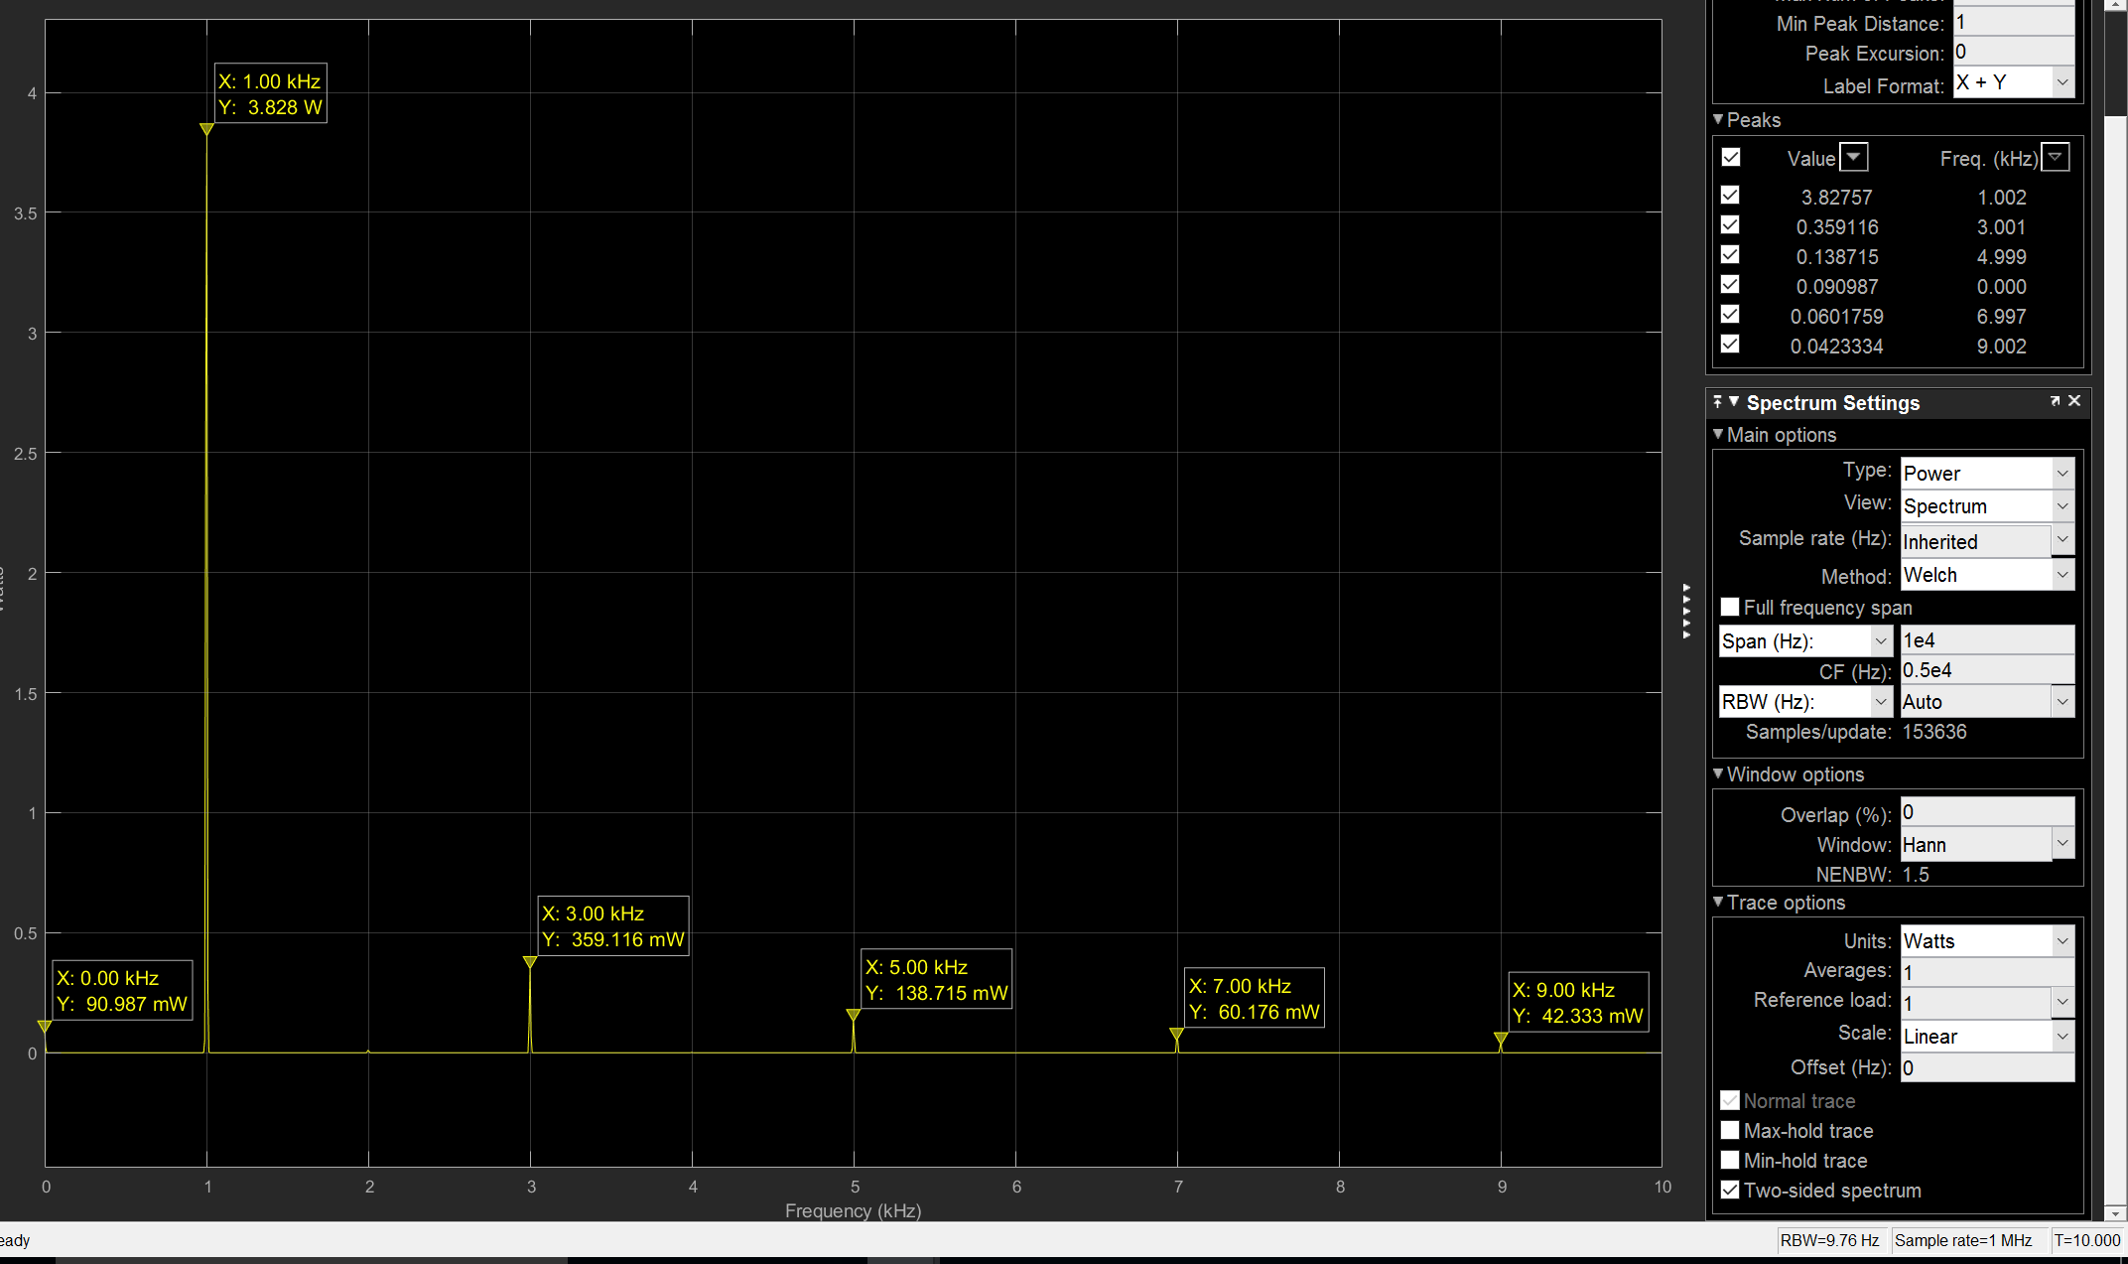

Figure 3 Normalized Spectrum

The Figure 3 show the frequency spectrum for the Dead zone sine wave and the peaks represent the normalized average power *Pav* (Watts) for the first 6 harmonics n =0, 1, 2, 3, 4 and 5 we can obtain *Xn* as follow:

Table 1 Fourier Series Coefficients from Simulink

|  |  |  |  |  |
| --- | --- | --- | --- | --- |
| m | $P_{AV}$ (Watts) | Pcapture | %Pav | Dm. |
| 0 | 10.8 | 0.00909 | 8.4 | 8.2786 |
| 1 | 10.8 | 7.746 | 71.72 | 14.65 |
| 2 | 10.8 | 8.4654 | 78.37 | 12.89 |
| 3 | 10.8 | 8.74264 | 80.9 | 19.24 |
| 4 | 10.8 | 8.863 | 82.06 | 3.624 |
| 5 | 10.8 | 8.947 | 82.84 | 1.792 |

For obtaining the Fourier series coefficient by calculation, we break down the ramp waveform in two limits L1, L2 see Figure 2. Per the Figure 2 we can calculate *S(t)* as follow:

$$s\left(t\right)=\left\{\begin{aligned}12t 0. s<t≤ 0.5 s \\ \\ \\ \\ 9-15t 0.6<t≤ 1 s \\ \\ \end{aligned}\right.$$

**Magnitude of the complex Fourier Series |*Dm*| calculations**

D0 = X0 = 8.278

Table 3 Polar Coefficients Results

|  |  |
| --- | --- |
| n |  |
| 0 | 8.2786 |
| 1 | 14.65 |
| 2 | 12.89 |
| 3 | 19.24 |
| 4 | 3.624 |
| 5 | 1.792 |

**Calculate the percentage of the total normalized average power %PAV for the summated polar *Xn* Fourier series coefficients using Parseval’s Theorem**

we used these equations below and the polar *Xn* Fourier coefficient values from Table 1:

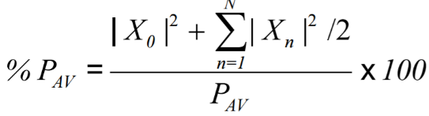

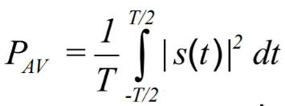***Eq****.****10***

***Eq. 11***

Where

🡪 Using MATLAB to integrate

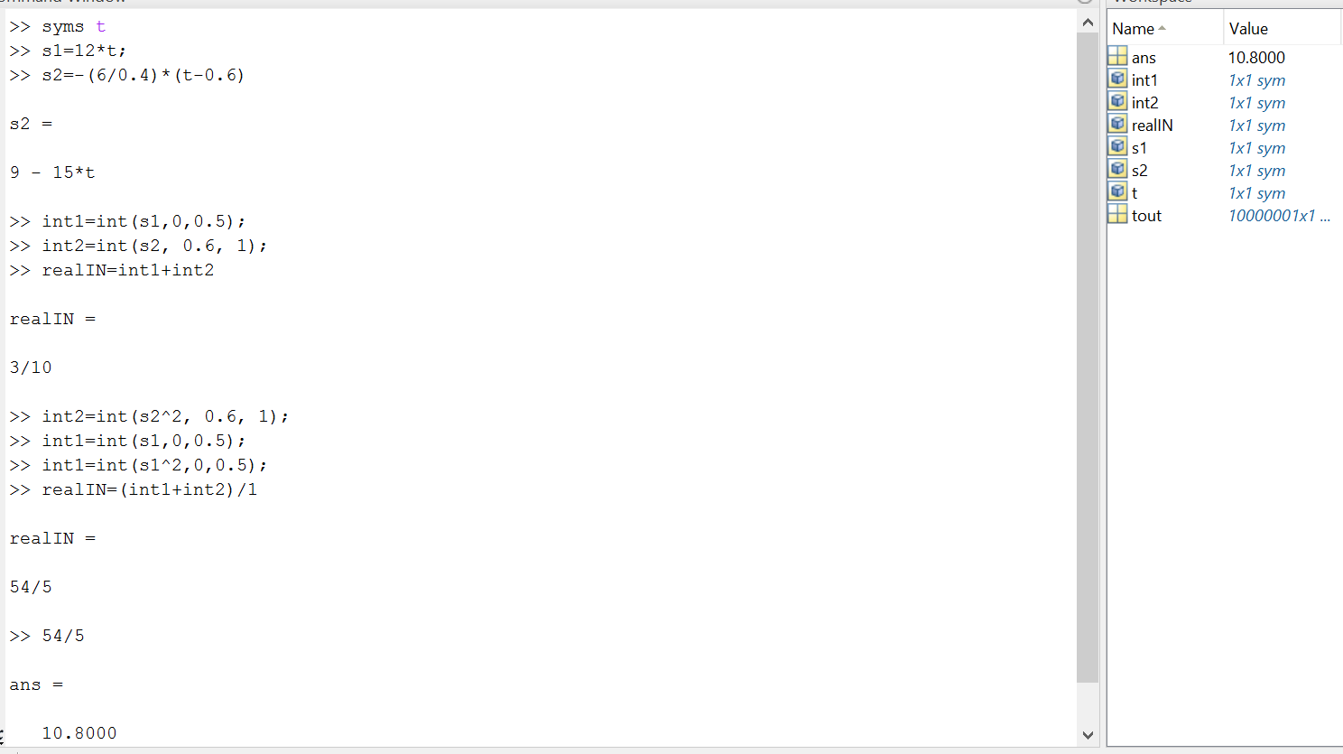

**The percentage of the total normalized power %PAV is for n = 0, 1, 2,3, 4, 5**

$$\%P_{AV}=\frac{(8.94766)}{10.8}*100=82.84\%$$

In our calculation from MATLAB we found the average (DC) to 3/10 and the root-mean-square (RMS) to $\sqrt{10.8}$

There is a difference between the value and I think it is since the average value is a simple mathematical average value while the RMS value is the average of the absolute value.

https://d.adroll.com/cm/aol/out

# conclusion/discussion

The purpose of this laboratory was to generate a periodic waveform signal and find it Fourier series characteristic such as *|Dm|,* and *Pav* from both Simulink and calculations. This laboratory was very difficult because it wasn’t easy to get the Simulink design of the periodic waveform which is an ascending linear ramp for the interval 0.6s starting from 0 to a peak amplitude of 6, 0 volts for the interval 0.1s and a descending linear ramp from 0 to –6 for the remainder of the period. Using the Parseval’s theorem we can see the more harmonics we add the more the percentage of the average power. Overall this laboratory gives us a much greater understanding on the theory behind the Fourier series.